***MINI PROJECT***

***RAILWAY RESERVATION SYSTEM***

***1.WELCOME PAGE:***

*<HTML><HEAD>*

*<link rel="stylesheet" href="ex.css">*

*</HEAD>*

*<BODY >*

*<P><CENTER>WELCOME</CENTER></P>*

*<center><button type="submit" class="btn" onclick='document.location.href="login.html"'>LOGIN</button></center><br/>*

*<center><button type="submit" class="btn" onclick='document.location.href="register.html"'>REGISTER</button></center><br/>*

*<center><button type="submit"class="btn" onclick='document.location.href="e-catering info.html"'>E-CATERING INFO</button></center><br/>*

*</body>*

*</html>*

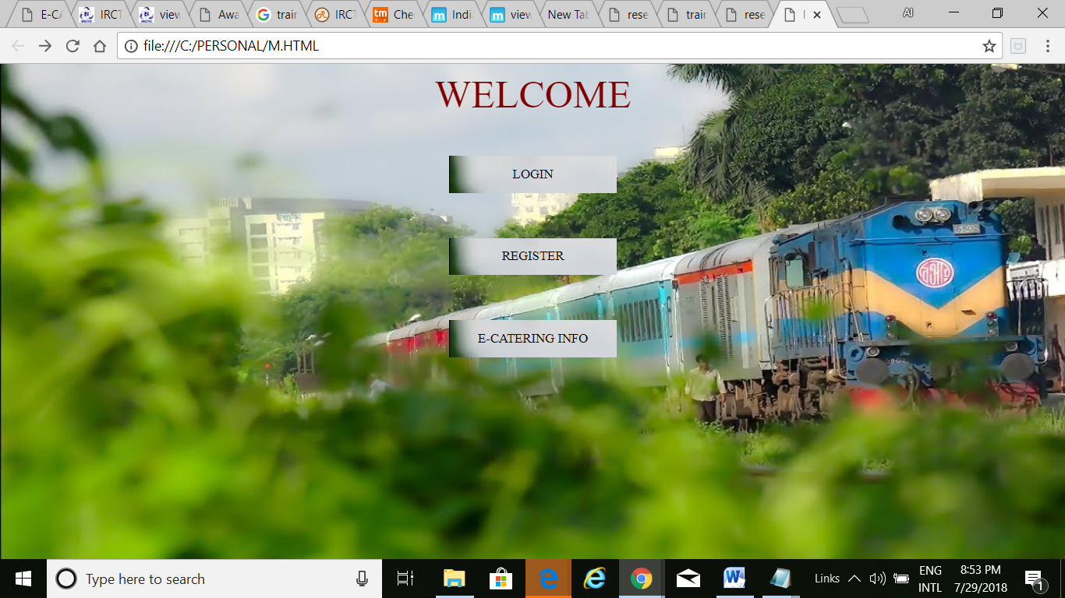

***2.LOGIN.HTML:***

*<html>*

*<head>*

*<link rel="stylesheet" href="hi.css">*

*<script>*

*function ValidateContactForm()*

*{*

*var username = document.ContactForm.Username;*

*var password = document.ContactForm.Password;*

*if (username.value == "")*

*{*

*window.alert("Please enter your name.");*

*username.focus();*

*return false;*

*}*

*if (password.value == "")*

*{*

*window.alert("Please enter your password");*

*password.focus();*

*return false;*

*}*

*}*

*</script>*

*</head>*

*<body>*

*<h2><center>LOGIN FORM</center></h2>*

*<div class="bg-img">*

*<form method="post"action="reserve.html"*

*name="ContactForm" onsubmit="return ValidateContactForm();">*

*<div class="container">*

*<p>Username: <input type="text"placeholder="Enter Username" name="Username"></p>*

*<p>Password: <input type="password" placeholder="Enter Password"name="Password"></p>*

*<p><input type="submit" class="btn"value="LOGIN" name="submit">*

*</div>*

*</form>*

*</div>*

*</body>*

*</html>*

***HI.CSS***

*body, html {*

*height: 100%;*

*font-family: "Times New Roman", Times, serif;*

*}*

*{*

*box-sizing: border-box;*

*}*

*.container {*

*position: absolute;*

*right: 0;*

*margin: 20px;*

*max-width: 300px;*

*padding: 16px;*

*background-color: white;*

*}*

*.bg-img {*

*background-image: url("hi.jpg");*

*min-height: 450px;*

*background-position: center;*

*background-repeat: no-repeat;*

*background-size: cover;*

*}*

*input[type=text], input[type=password] {*

*width: 100%;*

*padding: 15px;*

*margin: 5px 0 22px 0;*

*border: none;*

*background: #f1f1f1;*

*}*

*input[type=text]:focus, input[type=password]:focus {*

*background-color: #ddd;*

*outline: none;*

*}*

*.btn {*

*background-color: #4CAF50;*

*color: white;*

*padding: 16px 20px;*

*border: none;*

*cursor: pointer;*

*width: 100%;*

*opacity: 0.9;*

*}*

*.btn:hover {*

*opacity: 1;*

*}*

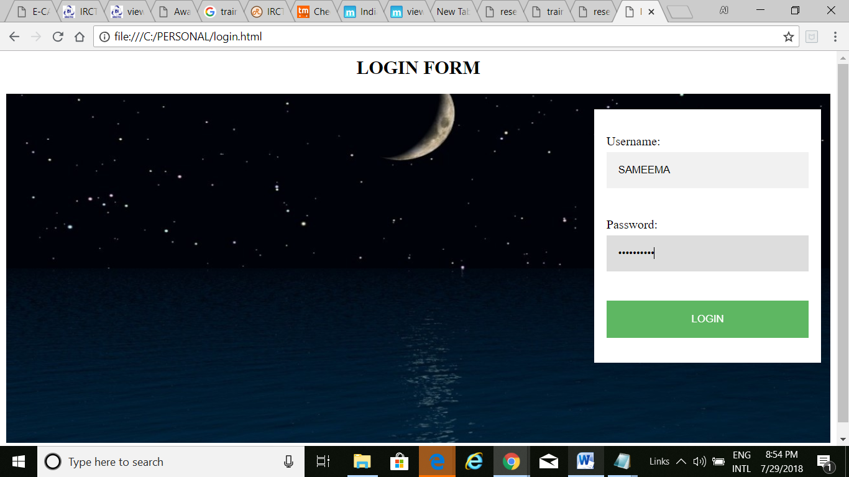

***ON CLICKING LOGIN IT WILL GO TO RESERVE.HTML PAGE***

***3.REGISTER.HTML:***

*<html>*

*<head>*

*<link rel="stylesheet" href="hiii.css">*

*<script>*

*function ValidateContactForm()*

*{*

*var firstname = document.ContactForm.Firstname;*

*var lastname = document.ContactForm.Lastname;*

*var email = document.ContactForm.Email;*

*var password = document.ContactForm.Password;*

*var dob= document.ContactForm.Dob;*

*var gender = document.ContactForm.Gender;*

*var marital = document.ContactForm.Marital;*

*var nationality= document.ContactForm.Nationality;*

*var aadharno = document.ContactForm.Aadharno;*

*var address= document.ContactForm.Address*

*var phoneno= document.ContactForm.Phoneno;*

*if (firstname.value == "")*

*{*

*window.alert("Please enter your firstname.");*

*firstname.focus();*

*return false;*

*}*

*if (lastname.value == "")*

*{*

*window.alert("Please enter your lastname.");*

*lastname.focus();*

*return false;*

*}*

*if (email.value == "")*

*{*

*window.alert("Please enter a valid e-mail address.");*

*email.focus();*

*return false;*

*}*

*if (email.value.indexOf("@", 0) < 0)*

*{*

*window.alert("Please enter a valid e-mail address.");*

*email.focus();*

*return false;*

*}*

*if (email.value.indexOf(".", 0) < 0)*

*{*

*window.alert("Please enter a valid e-mail address.");*

*email.focus();*

*return false;*

*}*

*if (password.value == "")*

*{*

*window.alert("Please enter your password");*

*password.focus();*

*return false;*

*}*

*if (dob.value=="")*

*{*

*alert("Please select dob.");*

*what.focus();*

*return false;*

*}*

*if (gender.selectedIndex < 1)*

*{*

*alert("Please select ur gender.");*

*gender.focus();*

*return false;*

*}*

*if (marital.selectedIndex < 1)*

*{*

*alert("Please select ur gender.");*

*marital.focus();*

*return false;*

*}*

*if (aadharno.value == "")*

*{*

*window.alert("Please enter your aadharno");*

*aadharno.focus();*

*return false;*

*}*

*if (nationality.selectedIndex < 1)*

*{*

*window.alert("Please enter your nationality");*

*nationality.focus();*

*return false;*

*}*

*if (address.value == "")*

*{*

*window.alert("Please enter your address");*

*address.focus();*

*return false;*

*}*

*if (phoneno.value == "")*

*{*

*window.alert("Please enter your phoneno");*

*phoneno.focus();*

*return false;*

*}*

*}*

*</script>*

*</head>*

*<body>*

*<h2><center>LOGIN FORM</center></h2>*

*<div class="bg-img">*

*<form method="post"action="reserve.html"*

*name="ContactForm" onsubmit="return ValidateContactForm();">*

*<div class="container">*

*<p>Firstname: <input type="text"placeholder="Enter firstname" name="Firstname"></p>*

*<p>Lastname: <input type="text"placeholder="Enter lastname" name="Lastname"></p>*

*<p>E-mail Address: <input type="text" placeholder="Enter Email" name="Email"></p>*

*<p>Password: <input type="password" placeholder="Enter Password" name="Password"></p>*

*<p>DOB: <input type="date" name="Dob"></p>*

*<p>Gender:<input type="radio"name="Gender">Male*

*<input type="radio"name="Gender">Female</p>*

*<p>Marital status:<input type="radio"name="Marital">Single*

*<input type="radio"name="Marital">Married</p>*

*<p>Aadharno: <input type="text" placeholder="Enter Aadharno" name="Aadharno"></p>*

*<p> Nationality: <select name="Nationality" >*

*<option value> </option>*

*<option value>India</option>*

*<option value>America</option>*

*<option value>Arabia</option>*

*<option value>Africa</option>*

*<option>Other</option>*

*</select></p><p>Address:<textarea rows="3"cols="30"placeholder="Enter Address" name="Address"id="Address"></textarea></p>*

*<p>Phoneno: <input type="text" placeholder="Enter phoneno" name="Phoneno"></p>*

*<p> <button type="submit" class="btn">Register </button></p>*

*<p><button type="reset" class="btn">Reset</button></p>*

*</div>*

*</form>*

*</div>*

*</body>*

*</html>*

***HIII.CSS***

*body, html {*

*height: 100%;*

*font-family: "Times New Roman", Times, serif;*

*}*

*{*

*box-sizing: border-box;*

*}*

*.container {*

*position: absolute;*

*left: 400;*

*margin: 20px;*

*max-width: 300px;*

*padding: 16px;*

*background-img:url("hiii.jpg");*

*}*

*.bg-img {*

*background-image: url("hiii.jpg");*

*min-height: 1200px;*

*background-position: center;*

*background-repeat: no-repeat;*

*background-size: cover;*

*}*

*input[type=text], input[type=password] {*

*width: 100%;*

*padding: 15px;*

*margin: 5px 0 22px 0;*

*border: none;*

*background: #f1f1f1;*

*}*

*input[type=text]:focus, input[type=password]:focus {*

*background-color: #ddd;*

*outline: none;*

*}*

*.btn {*

*background-color: red;*

*color: white;*

*padding: 16px 20px;*

*border: none;*

*cursor: pointer;*

*width: 100%;*

*opacity: 0.9;*

*}*

*.btn:hover {*

*opacity: 1;*

*}*

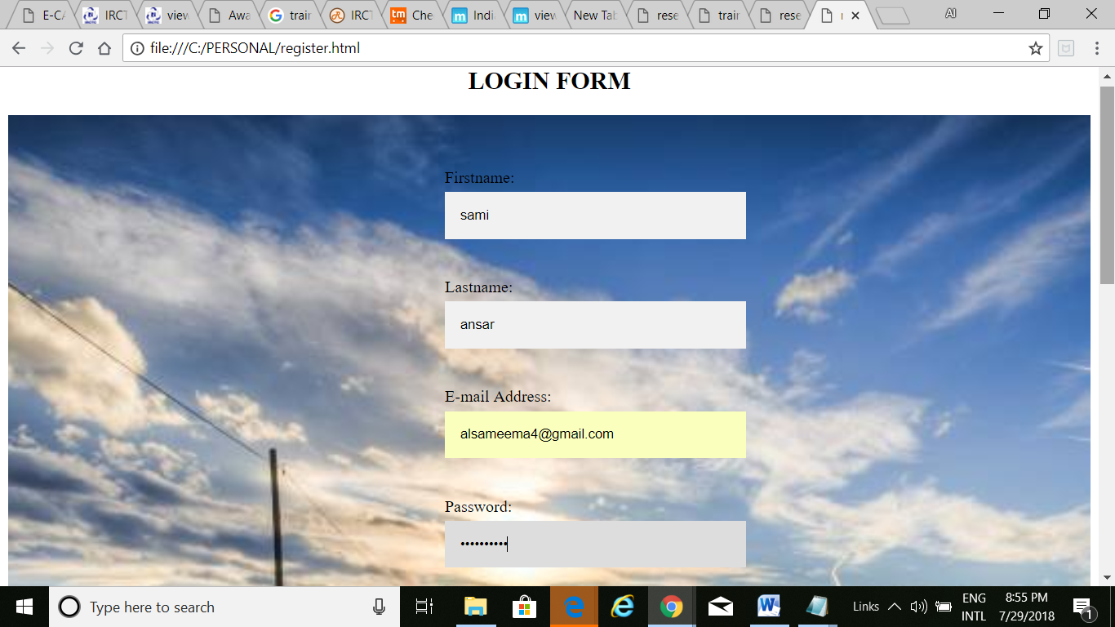

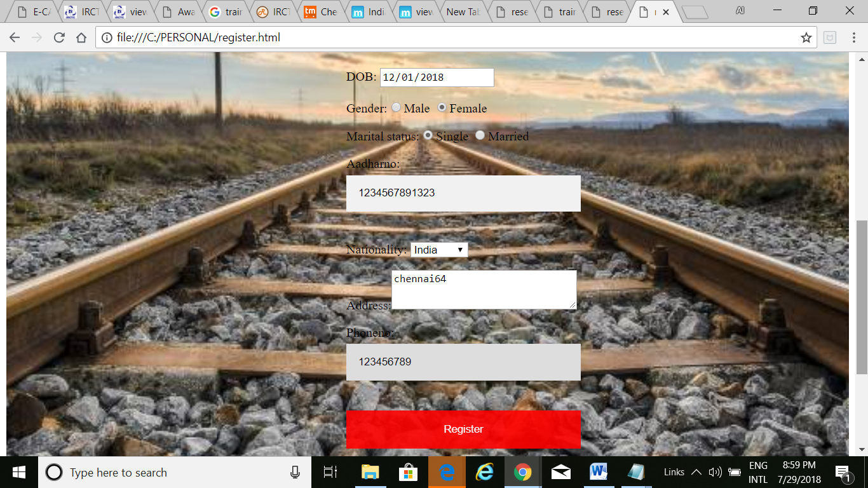

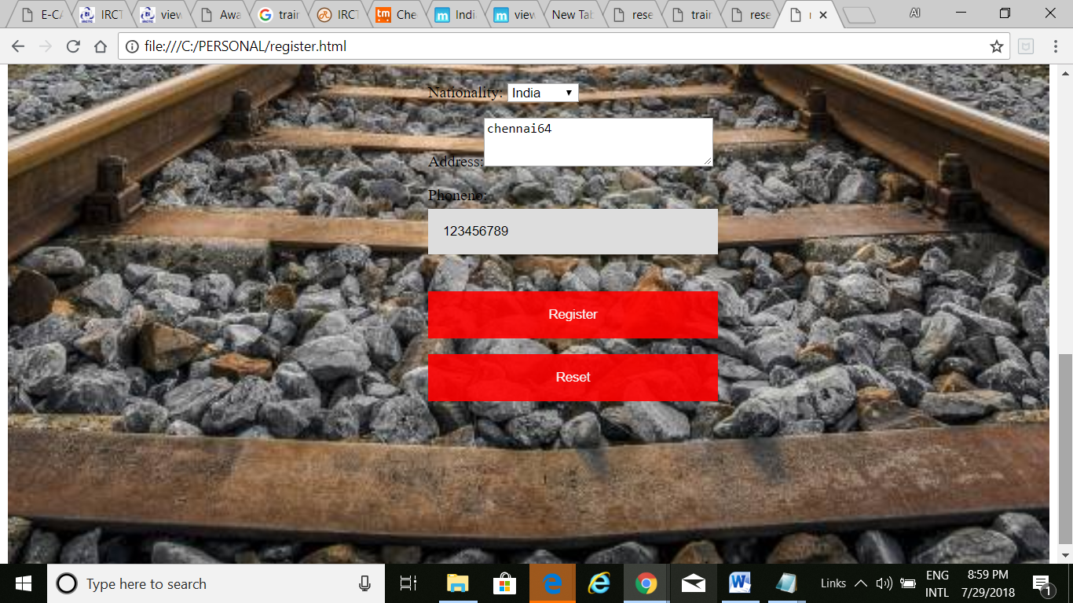

***4.RESERVE.HTML:***

*<html>*

*<head>*

*<link rel="stylesheet" href="hiii.css">*

*<script>*

*function ValidateContactForm()*

*{*

*var journeydate = document.ContactForm.Journeydate;*

*var journeyclass= document.ContactForm.Journeyclass;*

*var no.of.passengers= document.ContactForm.No.of.passengers;*

*var from= document.ContactForm.From;*

*var to= document.ContactForm.To;*

*if (from.value == "")*

*{*

*window.alert(" REQUIRED.");*

*from.focus();*

*return false;*

*}*

*if (to.value == "")*

*{*

*window.alert(" REQUIRED.");*

*from.focus();*

*return false;*

*}*

*if (journeyclass== "")*

*{*

*window.alert("CLASS IS REQUIRED");*

*to.focus();*

*return false;*

*}*

*}*

*if (no.of.passengers== "")*

*{*

*window.alert("PASSENGERS IS REQUIRED");*

*no.of.passengers.focus();*

*return false;*

*}*

*}*

*</script>*

*</head>*

*<body>*

*<h2><center>BOOK YOUR TICKET</center></h2>*

*<div class="bg-img">*

*<form method="post"action="done.html"*

*name="ContactForm" onsubmit="return ValidateContactForm();">*

*<div class="container">*

*<p> Journey Date:<input type="date"name="Journeydate"></p>*

*<p>*

*Journey Class: <select name="Journeyclass" >*

*<option value>AC FIRST CLASS(1A)</option>*

*<option value>FIRST CLASS(FC)</option>*

*<option value>AC 2 TIER</option>*

*<option value>AC 3 TIER</option>*

*<option>AC CHAIR CAR</option>*

*<option>SLEEPER</option>*

*<option>SECOND SITTING</option>*

*</select></p>*

*<p> No.of.Passengers<input type="text" name="Noofpassengers"></p>*

*<input type="button" class="btn"value="FIND TRAINS"onclick='document.location.href="train.html"'</button>*

*<p> From:<input type="text" placeholder="CITY"name="from"></p>*

*<p> To:<input type="text" placeholder="CITY"name="to"></p>*

*<button type="submit" class="btn">REGISTER</button>*

*</div>*

*</form>*

*</div>*

*</body>*

*</html>*

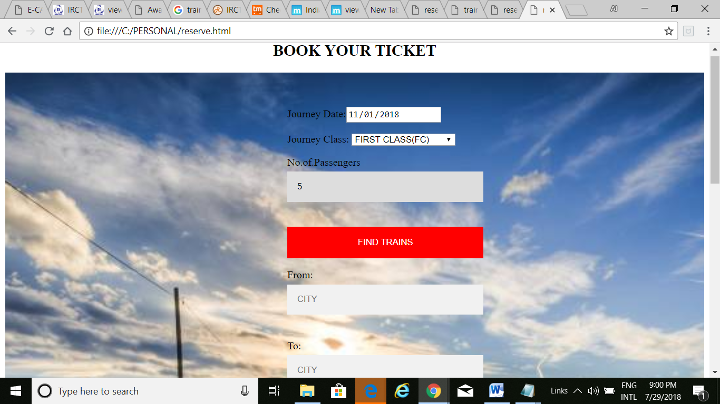

***5.TRAIN.HTML:***

*<html>*

*<body>*

*<link rel="stylesheet" href="tr.css">*

*<table border="2"width="50%"align=center>*

*<tr>*

*<th>Train Number</th><th>Train Name</th><th>Source Stn</th><th>Source Dep. Time</th><th>Train Destination Stn</th><th>Dest. Arr. Time</th><th>Dep Days / Runs On</th></tr></thead>*

*<tbody>*

*<tr>*

*<td><a href="https://www.mapsofindia.com/railway-timetable/bandra-terminus-to-delhi-s-rohilla-route-of-dee-garibrath.html">12216</a></td>*

*<td>BANDRA TERMINUS - DELHI S ROHILLA Garibrath Express</td>*

*<td>BANDRA TERMINUS</td>*

*<td>12:45:00</td>*

*<td>DELHI S ROHILLA</td>*

*<td>12:15:00</td>*

*<td>TUE,WED,FRI,SUN</td>*

*</tr>*

*<tr>*

*<td><a href="https://www.mapsofindia.com/railway-timetable/yesvantpur-jn-to-kochuveli-route-of-kochuveli-gr.html">12257</a></td>*

*<td>YESVANTPUR JN - KOCHUVELI Garibrath Express</td>*

*<td>YESVANTPUR JN</td>*

*<td>21:00:00</td>*

*<td>KOCHUVELI</td>*

*<td>13:00:00</td>*

*<td>TUE,THU,SUN</td>*

*</tr>*

*<tr>*

*<td><a href="https://www.mapsofindia.com/railway-timetable/kochuveli-to-yesvantpur-jn-route-of-yesvantpur-exp.html">12258</a></td>*

*<td>KOCHUVELI - YESVANTPUR JN Garibrath Express</td>*

*<td>KOCHUVELI</td>*

*<td>17:00:00</td>*

*<td>YESVANTPUR JN</td>*

*<td>09:30:00</td>*

*<td>MON,WED,FRI</td>*

*</tr>*

*<tr>*

*<td><a href="https://www.mapsofindia.com/railway-timetable/kolkata-to-patna-jn-route-of-pnbe-garib-rath.html">12359</a></td>*

*<td>KOLKATA - PATNA JN Garibrath Express</td>*

*<td>KOLKATA</td>*

*<td>20:05:00</td>*

*<td>PATNA JN</td>*

*<td>05:30:00</td>*

*<td>TUE,THU,SAT</td>*

*</tr>*

*<tr>*

*<td><a href="https://www.mapsofindia.com/railway-timetable/patna-jn-to-kolkata-route-of-kol-garib-rath.html">12360</a></td>*

*<td>PATNA JN - KOLKATA Garibrath Express</td>*

*<td>PATNA JN</td>*

*<td>20:05:00</td>*

*<td>KOLKATA</td>*

*<td>05:15:00</td>*

*<td>WED,FRI,SUN</td>*

*</tr>*

*<tr>*

*<td><a href="https://www.mapsofindia.com/railway-timetable/kolkata-to-guwahati-route-of-ghy-garib-rath.html">12517</a></td>*

*<td>KOLKATA - GUWAHATI Garibrath Express</td>*

*<td>KOLKATA</td>*

*<td>21:40:00</td>*

*<td>GUWAHATI</td>*

*<td>15:55:00</td>*

*<td>THU,SUN</td>*

*</tr>*

*<tr>*

*<td><a href="https://www.mapsofindia.com/railway-timetable/guwahati-to-kolkata-route-of-kol-garib-rath.html">12518</a></td>*

*<td>GUWAHATI - KOLKATA JAN SHADABTHI Express</td>*

*<td>GUWAHATI</td>*

*<td>21:00:00</td>*

*<td>KOLKATA</td>*

*<td>15:00:00</td>*

*<td>WED,SAT</td>*

*</tr>*

*<tr>*

*<td><a href="https://www.mapsofindia.com/railway-timetable/lucknow-ne-to-raipur-jn-route-of-ljn-r-garibrath.html">12535</a></td>*

*<td>LUCKNOW NE - RAIPUR JN Garibrath Express</td>*

*<td>LUCKNOW NE</td>*

*<td>14:10:00</td>*

*<td>RAIPUR JN</td>*

*<td>07:15:00</td>*

*<td>MON,THU</td>*

*</tr>*

*<tr>*

*<td><a href="https://www.mapsofindia.com/railway-timetable/raipur-jn-to-lucknow-ne-route-of-ljn-garibrath.html">12536</a></td>*

*<td>RAIPUR JN - LUCKNOW NE PEARL Express</td>*

*<td>RAIPUR JN</td>*

*<td>12:20:00</td>*

*<td>LUCKNOW NE</td>*

*<td>05:05:00</td>*

*<td>TUE,FRI</td>*

*</tr>*

*<tr>*

*<td><a href="https://www.mapsofindia.com/railway-timetable/jaynagar-to-anand-vihar-trm-route-of-jyg-anvt-g-rath.html">12569</a></td>*

*<td>JAYNAGAR - ANAND VIHAR TRM Garibrath Express</td>*

*<td>JAYNAGAR</td>*

*<td>12:00:00</td>*

*<td>ANAND VIHAR TRM</td>*

*<td>08:20:00</td>*

*<td>MON,FRI</td>*

*</tr>*

*<tr>*

*<td><a href="https://www.mapsofindia.com/railway-timetable/anand-vihar-trm-to-jaynagar-route-of-jyg-garib-rath.html">12570</a></td>*

*<td>ANAND VIHAR TRM - JAYNAGAR Garibrath Express</td>*

*<td>ANAND VIHAR TRM</td>*

*<td>16:55:00</td>*

*<td>JAYNAGAR</td>*

*<td>13:35:00</td>*

*<td>TUE,SAT</td>*

*</tr>*

*<tr>*

*<td><a href="https://www.mapsofindia.com/railway-timetable/lucknow-ne-to-bhopal-jn-route-of-ljn-bpl-g-r.html">12593</a></td>*

*<td>LUCKNOW NE - BHOPAL JN Garibrath Express</td>*

*<td>LUCKNOW NE</td>*

*<td>22:45:00</td>*

*<td>BHOPAL JN</td>*

*<td>09:35:00</td>*

*<td>SAT</td>*

*</tr>*

*<tr>*

*<td><a href="https://www.mapsofindia.com/railway-timetable/bhopal-jn-to-lucknow-ne-route-of-ljn-garib-rath.html">12594</a></td>*

*<td>BHOPAL JN - LUCKNOW NE Garibrath Express</td>*

*<td>BHOPAL JN</td>*

*<td>22:45:00</td>*

*<td>LUCKNOW NE</td>*

*<td>09:45:00</td>*

*<td>SUN</td>*

*</tr>*

*<tr>*

*<td><a href="https://www.mapsofindia.com/railway-timetable/chennai-central-to-h-nizamuddin-route-of-nzm-garib-rath.html">12611</a></td>*

*<td>CHENNAI CENTRAL - H NIZAMUDDIN Garibrath Express</td>*

*<td>CHENNAI CENTRAL</td>*

*<td>06:10:00</td>*

*<td>H NIZAMUDDIN</td>*

*<td>10:25:00</td>*

*<td>SAT</td>*

*</tr>*

*<tr>*

*<td><a href="https://www.mapsofindia.com/railway-timetable/puri-to-yesvantpur-jn-route-of-puri-ypr-g-rath.html">22883</a></td>*

*<td>PURI - YESVANTPUR JN Garibrath Express</td>*

*<td>PURI</td>*

*<td>15:00:00</td>*

*<td>YESVANTPUR JN</td>*

*<td>20:00:00</td>*

*<td>FRI</td>*

*</tr>*

*<tr>*

*<td><a href="https://www.mapsofindia.com/railway-timetable/yesvantpur-jn-to-puri-route-of-puri-garib-rath.html">22884</a></td>*

*<td>YESVANTPUR JN - PURI Garibrath Express</td>*

*<td>YESVANTPUR JN</td>*

*<td>22:40:00</td>*

*<td>PURI</td>*

*<td>05:40:00</td>*

*<td>SAT</td>*

*</tr>*

*<tr>*

*<td><a href="https://www.mapsofindia.com/railway-timetable/trivandrum-cntl-to-kozhikkode-route-of-jan-shatabdi-exp.html">12076</a></td>*

*<td>TRIVANDRUM CNTL - KOZHIKKODE Jan-Shatabdi Express</td>*

*<td>TRIVANDRUM CNTL</td>*

*<td>06:00:00</td>*

*<td>KOZHIKKODE</td>*

*<td>13:00:00</td>*

*<td>MON,TUE,WED,THU,FRI,SAT,SUN</td>*

*</tr>*

*<tr>*

*<td><a href="https://www.mapsofindia.com/railway-timetable/chennai-central-to-vijayawada-jn-route-of-jan-shatabdi-exp.html">12077</a></td>*

*<td>CHENNAI CENTRAL - VIJAYAWADA JN Jan-Shatabdi Express</td>*

*<td>CHENNAI CENTRAL</td>*

*<td>07:35:00</td>*

*<td>VIJAYAWADA JN</td>*

*<td>14:45:00</td>*

*<td>MON,WED,THU,FRI,SAT,SUN</td>*

*</tr>*

*<tr>*

*<td><a href="https://www.mapsofindia.com/railway-timetable/vijayawada-jn-to-chennai-central-route-of-jan-shatabdi-exp.html">12078</a></td>*

*<td>VIJAYAWADA JN - CHENNAI CENTRAL Jan-Shatabdi Express</td>*

*<td>VIJAYAWADA JN</td>*

*<td>15:20:00</td>*

*<td>CHENNAI CENTRAL</td>*

*<td>22:35:00</td>*

*<td>MON,WED,THU,FRI,SAT,SUN</td>*

*</tr>*

*<tr>*

*<td><a href="https://www.mapsofindia.com/railway-timetable/ksr-bengaluru-to-hubballi-jn-route-of-jan-shatabdi-exp.html">12079</a></td>*

*<td>KSR BENGALURU - HUBBALLI JN Jan-Shatabdi Express</td>*

*<td>KSR BENGALURU</td>*

*<td>06:00:00</td>*

*<td>HUBBALLI JN</td>*

*<td>13:25:00</td>*

*<td>MON,TUE,WED,THU,FRI,SAT,SUN</td>*

*</tr>*

*<tr>*

*<td><a href="https://www.mapsofindia.com/railway-timetable/mayiladuturai-j-to-coimbatore-jn-route-of-jan-shatabdi-exp.html">12083</a></td>*

*<td>MAYILADUTURAI J - COIMBATORE JN Jan-Shatabdi Express</td>*

*<td>MAYILADUTURAI J</td>*

*<td>14:50:00</td>*

*<td>COIMBATORE JN</td>*

*<td>21:15:00</td>*

*<td>MON,WED,THU,FRI,SAT,SUN</td>*

*</tr>*

*<tr>*

*<td><a href="https://www.mapsofindia.com/railway-timetable/coimbatore-jn-to-mayiladuturai-j-route-of-jan-shatabdi-exp.html">12084</a></td>*

*<td>COIMBATORE JN - MAYILADUTURAI J Jan-Shatabdi Express</td>*

*<td>COIMBATORE JN</td>*

*<td>07:10:00</td>*

*<td>MAYILADUTURAI J</td>*

*<td>13:40:00</td>*

*<td>MON,WED,THU,FRI,SAT,SUN</td>*

*</tr>*

*<tr>*

*<td><a href="https://www.mapsofindia.com/railway-timetable/patna-jn-to-ranchi-route-of-rnc-janshatabdi.html">12365</a></td>*

*<td>PATNA JN - RANCHI Jan-Shatabdi Express</td>*

*<td>PATNA JN</td>*

*<td>06:00:00</td>*

*<td>RANCHI</td>*

*<td>13:55:00</td>*

*<td>MON,TUE,WED,THU,FRI,SAT,SUN</td>*

*</tr>*

*<tr>*

*<td><a href="https://www.mapsofindia.com/railway-timetable/ranchi-to-patna-jn-route-of-pnbe-janshatabdi.html">12366</a></td>*

*<td>RANCHI - PATNA JN Jan-Shatabdi Express</td>*

*<td>RANCHI</td>*

*<td>14:25:00</td>*

*<td>PATNA JN</td>*

*<td>22:15:00</td>*

*<td>MON,TUE,WED,THU,FRI,SAT,SUN</td>*

*</tr>*

*</table>*

*<button type="submit" class="btn"onclick="return.html">Checked</button>*

*</body>*

*</html>*

***TR.CSS:***

*.btn {*

*background-color: gray;*

*color: white;*

*padding: 16px 20px;*

*border: none;*

*cursor: pointer;*

*width: 100%;*

*opacity: 0.9;*

*}*

*.btn:hover {*

*opacity: 1;*

*}*

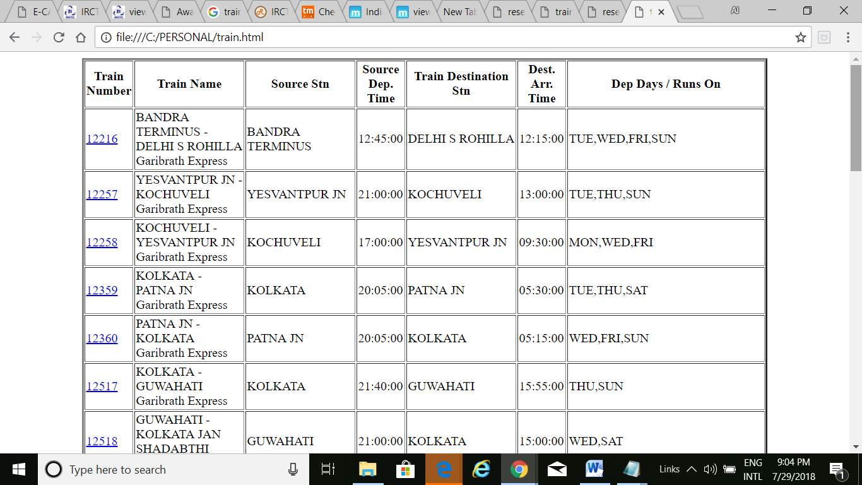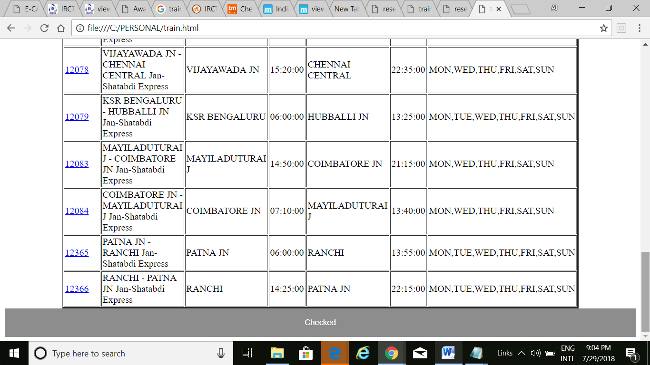

***ON CLICKING CHECKED IT WILL RETURN TO THE PAGE***

***RESERVE.HTML***

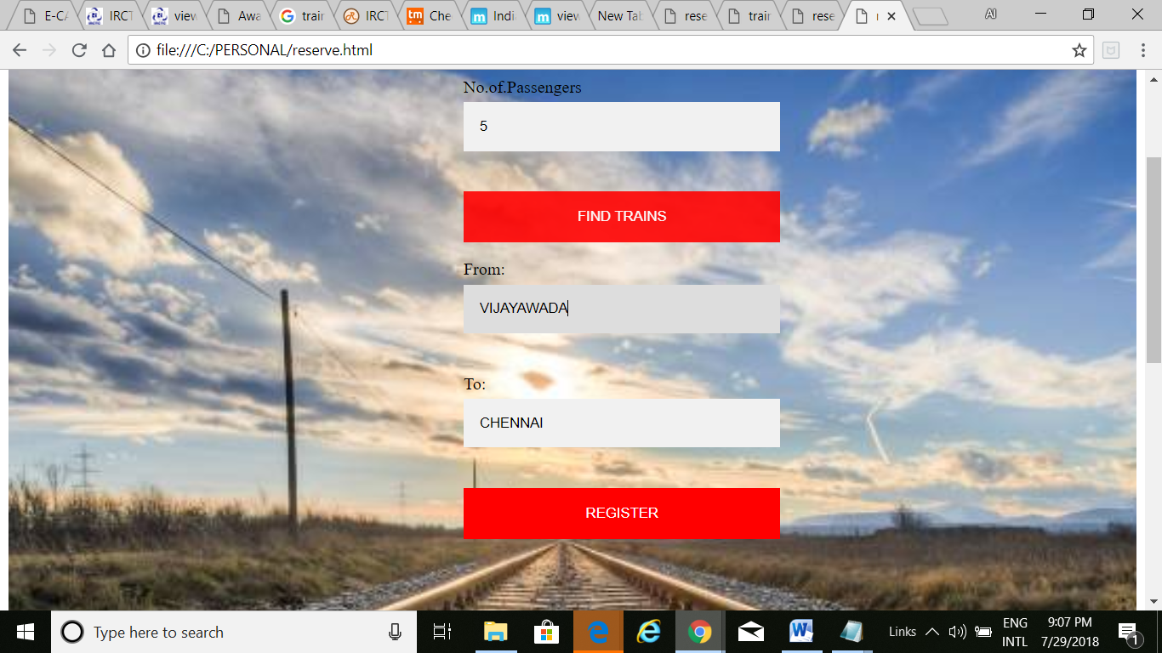

***6.DONE.HTML:***

*<html>*

*<body background="M111.jpg">*

*<p><h2><center>RESERVATION DONE</center></h2></p>*

*<br><br>*

*<center><h1>"HAVE A HAPPY JOURNEY"</h3></center>*

*</br></br>*

*</body>*

*</html>*

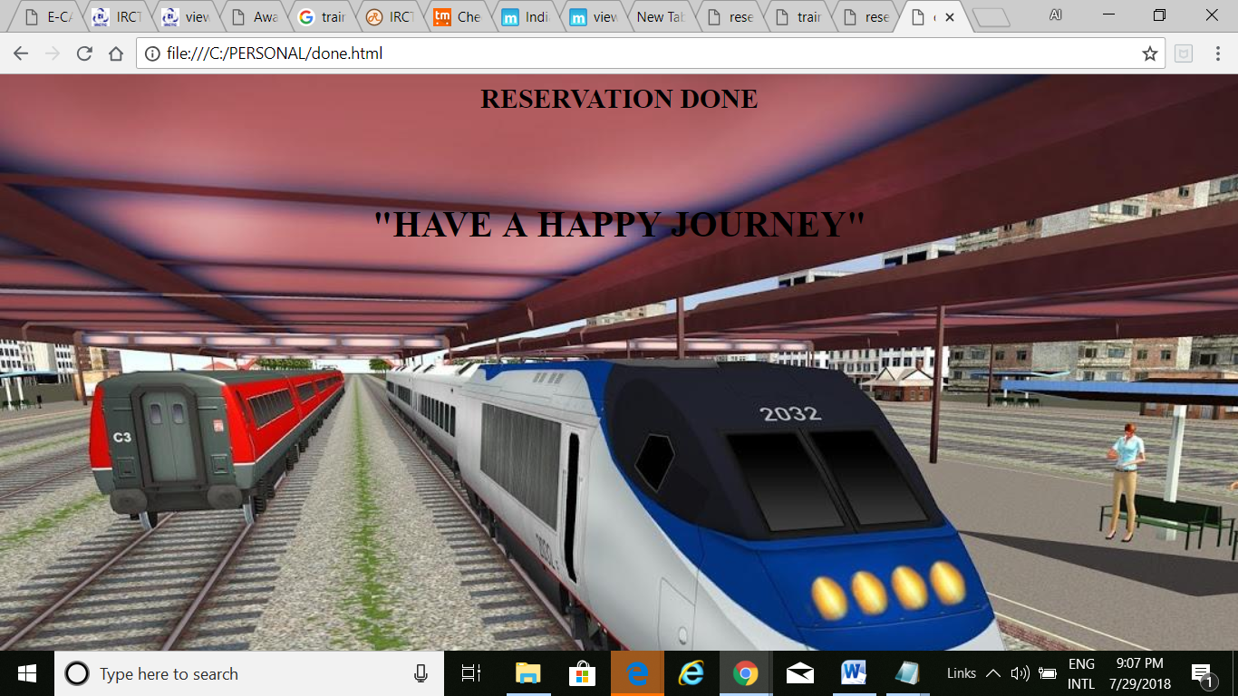

***7.E-CATERING INFO.HTML:***

*<html>*

*<head>*

*<frameset rows="20%,80%">*

*<frame src="next.html"></frame>*

*<frame src="ne.html"></frame>*

*</frameset>*

*</head>*

*</html>*

***NEXT.HTML:***

*<html>*

*<body background="food.jpg">*

*<table>*

*<tr>*

*<td><img src="1.jpg"></td>*

*<td><h3><center><marquee bgcolor="yellow">IRCTC E-CATERING OFFERS</marquee></center></h3>*

*</tr>*

*</table>*

*</body>*

*</html>*

***NE.HTML:***

*<html>*

*<body bgcolor="lightyellow">*

*<p><center><h2>IRCTC E-Catering Offers || IRCTC Brings AN Amazing Offer Where You Can Get 50% Cashback On Trains Foods Ordering On Minimum Order Of Rs 300.</h2></center></p>*

*<p>We Have Brought A Great Offer On IRCTC Food Ordering OnlineWith IRCTC E-Catering Online Service.*

*New Train Ticket Food Booking Using Below Given Links Which Through You Can Get 50% Cashback ON IRCTC Catering Food Booking. </p>*

*<center><img src="irc.jpg"></center>*

*<center><img src="irc1.jpg"></center>*

*<p>IRCTC Is Running A Great offer Where You Can Get Flat 50% Cashback On Your Online IRCTC Food Ordering With IRCTC App Only.</p>*

*<p>IRCTC IS Serving IN Limited Numbers Of Train Which Has No Pantry Car Inside. Passenger Are Free To Book Foods And Dinners Online On Trains Only.*

*An SMS WIll Be Sent On Your Mobile Number With PNR Number. </p>*

*<p><h3>*

*Terms & Conditions for 50 % Cash Back Offer on E-Catering</h3>*

*<ul>*

*<li>The cash back offer is only valid for meals booked through IRCTC and having a value of more than Rs 300 in a single order. </li>*

*<li>The payment mode used for booking the meal should be prepaid mode i.e. using the payment gateway (HDFC PG or Paytm) to avail the Cash Back Offer </li>*

*<li>The offer is not valid if the order is partially/Fully cancelled and the booking amount is reduced to less than Rs.300. </li>*

*<li>The cash back would be processed only after the delivery date. </li>*

*<li>The cash back would be paid into the same account through which the payment was made for the meal booking. </li>*

*<li>The customer would be intimated once the cash back is processed by IRCTC. </li>*

*<li>Any queries regarding the same should be sent to customercare.ecatering@irctc.com or call at Toll free No. 1323.</li>*

*</ul>*

*<p><h3>How To Get/Claim IRCTC E-Catering Offers </h3>*

*<ol>*

*<li>Visit Here E-Carting.irctc.co.in || Click Here To Know Your Station Code </li>*

*<li>Choose Your Station Code Number & Hit On Search Button </li>*

*<li>You Will Be Shown E-Catering Vendor List Available</li>*

*<li>Choose Your Menu And Make Order Of Rs 300 Minimum</li>*

*<li>Enter Your Seat Number Or PNR Number.</li>*

*<li>Pay Using Paytm Or HDFC Card Or Any Other Best Mode Of Payment To Get Cashback</li>*

*</ol>*

*</body>*

*</html>*

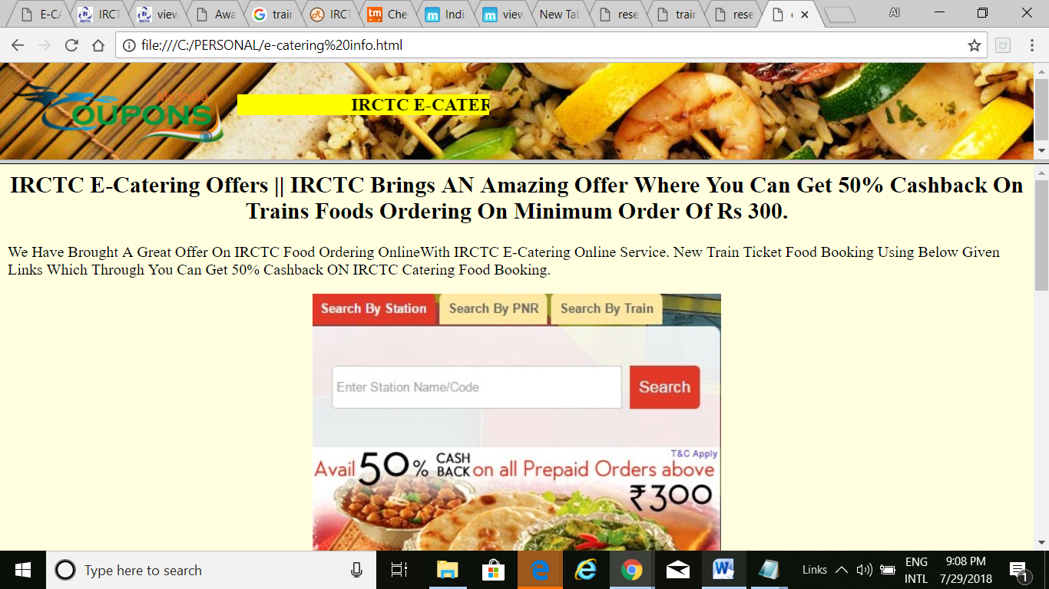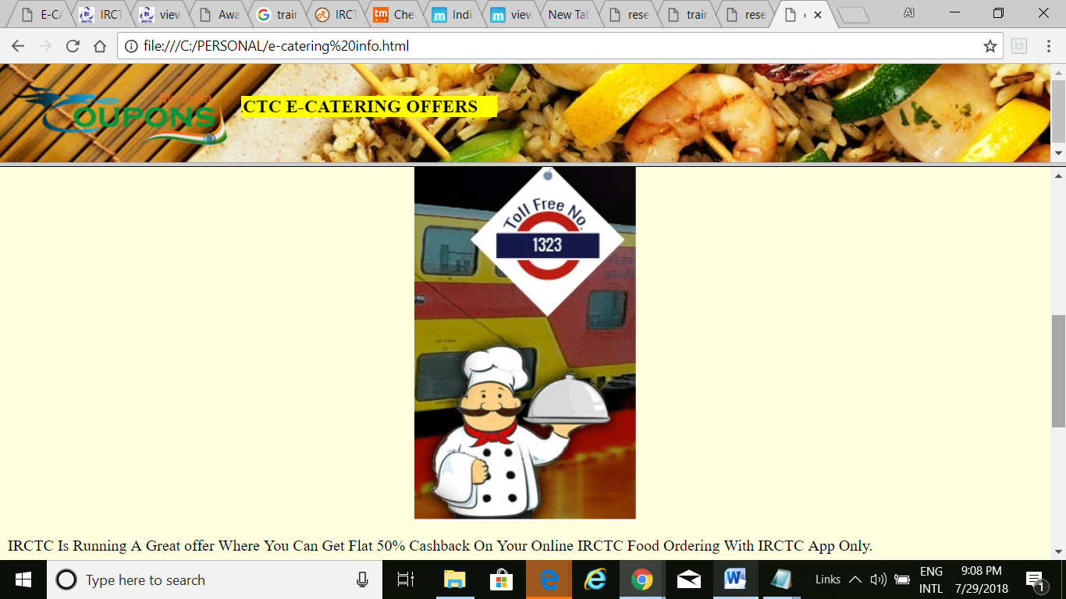

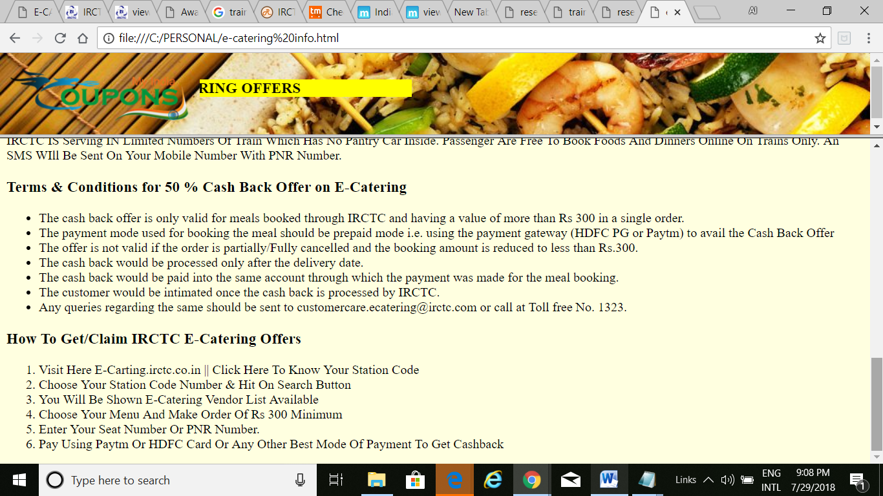

***PROJECT DONE***